|  |  |  |  |
| --- | --- | --- | --- |
| **osztály** | **tantárgy** | **tanár** | **tananyag** |
| 11.A | Kémia angol nyelven | Barabás Gergő | 1. Oxigéntartalmú, összetett funkciós csoportot tartalmazó szerves vegyületek:    1. karbonsavak (hangyasav, ecetsav) és tulajdonságaik    2. észterek (etil-acetát, gyümölcsészterek, trigliceridek) 2. Nitrogéntartalmú szerves vegyületek    1. aminok (C1-C3 aminok, alanin)    2. amidok (formamid, acetamid, karbamid)    3. aminosavak (glicin) és fehérjék    4. heteroaromások (piridin, pirimidin, pirrol, imidazol, purin) 3. Szénhidrátok    1. csoportosítás (szénatomszám, oxocsoport helyzete szerint) és általános jellemzés    2. monoszacharidok (glükóz, fruktóz, ribóz, dezoxiribóz)    3. diszacharidok (maltóz, cellobióz, szacharóz, laktóz)    4. poliszacharidok (cellulóz, keményítő) 4. Nukleinsavak    1. felépítés, jelentőség    2. DNS és RNS 5. Műanyagok    1. PE, PP, PS, PVC, PTFE, PMMA    2. nejlon, PET, bakelit    3. kaucsuk és gumi, cellulózalapú műanyagok |

|  |  |  |  |
| --- | --- | --- | --- |
|  | **Ethyl alcohol** | **Carbolic acid** | **Acetic acid** |
| Structural formula |  |  |  |
| Systematic name |  |  |  |
| The pH of its aqueous solution |  |  |  |
| Reaction with baking soda |  |  |  |
| Reaction with water |  |  |  |
| Reaction with soda lye |  |  |  |
| Reaction with sodium |  |  |  |
| Name of organic product |  |  |  |

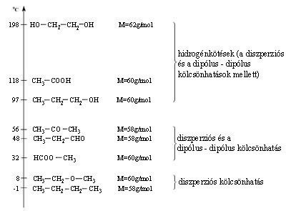

# What is the BP of carboxylic acid like? (Compared to monovalent compounds.)

# What enables glycol to get ahead of acetic acid.

# Where can you expect the BP of esters?

#Give the formula of the ester suitable for comparison.

Compare **acetic and formic acid** with the help of the hints. (Give equations)

1. acetates

2. Buffering effect, commonly used solvent

3. Common in bee and ant venom

4. distinctive sour taste and pungent smell

5. ethanoates

6. formiates

7. heater pillows

8. It can be oxidised by silver mirror test

9. It my show aldehyde behaviour

10. lead sugar

11. Liquid of highly pungent penetrating odour

12. Liquid, but water-free form: glacial ………… acid is solid

13. methanoates

14. Possible oxidation by bromine water

15. Raw material (drug industry, cellulose acetate production)

16. reaction with soda lye

17. reaction with sodium

18. reaction with sodium hydroxide

19. reaction with water

20. Simplest of all

21. Used in textile industry and against rheumatism

22. Vinegar is a dilute solution of it

**Revision on N-containing compounds**

**[1.]** Name the following compounds. Circle their functional groups and name them.

|  |  |  |  |
| --- | --- | --- | --- |
| a) | b) | c) | d) |

Names:

Functional group:

**[2.]** Give the reaction equation and name the products.

a) methyl amine + water:

pH of the solution:

b) methyl amine + hydrochloric acid:

**[3.]** Name the compounds and circle the amide group.

|  |  |  |  |
| --- | --- | --- | --- |
| A) | B) | C) | D) |

Classify the compounds:

* 1. primary:
  2. secondary:
  3. tertiary:

1. Which ones can form H bonds?
2. Which ones are solid at STP?
3. Give the formation equation of A):

**[4.]** Write the letters in the appropriate place.

pyridine

1. It has aromatic structure.

pyrrole

2. Its molecular formula is C5H5N.

3. It can form H bonds.

4. It is liquid at STP.

5. It is soluble in water.

imidazole

6. It can act as an acid and as a base.

7. It builds up chlorophyll.

8. It forms molecular lattice in solid state.

9. Its molecule is polar.

10. Its ring is built up by 5 atoms.

**[5.]** Give the structure of the simplest amino acid. Name it.

What does zwitter ion mean? How is it formed?

***Nucleic*** ***acids***

|  |  |  |  |  |  |
| --- | --- | --- | --- | --- | --- |
| dblhelx1 |  | | | | |
|  | | Name | Formula | Molar mass |
| Adenine (A) | C5H5N5 | 135,13 |
| Cytosine (C) | C4H5N3O | 111,10 |
| Uracil (U) | C4H4N2O2 | 112,09 |
| Guanine (G) | C5H5N5O | 151,13 |
| Thymine (T) | C5H6N2O2 | 126,12 |
|  | | |

|  |  |  |
| --- | --- | --- |
| Full name |  |  |
| Mineral component |  |  |
| Sugar unit |  |  |
| Heterocyclic bases | 1. . 2. . 3. . | 1. . 2. . 3. . 4. . |

**[1.]** Name the following sugars. Label them according to …

* number of C atoms and oxo group
* number of sugar units

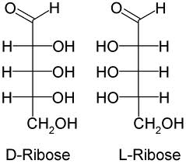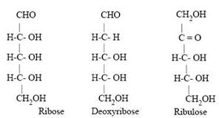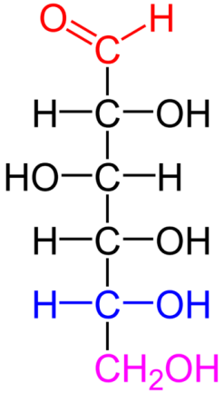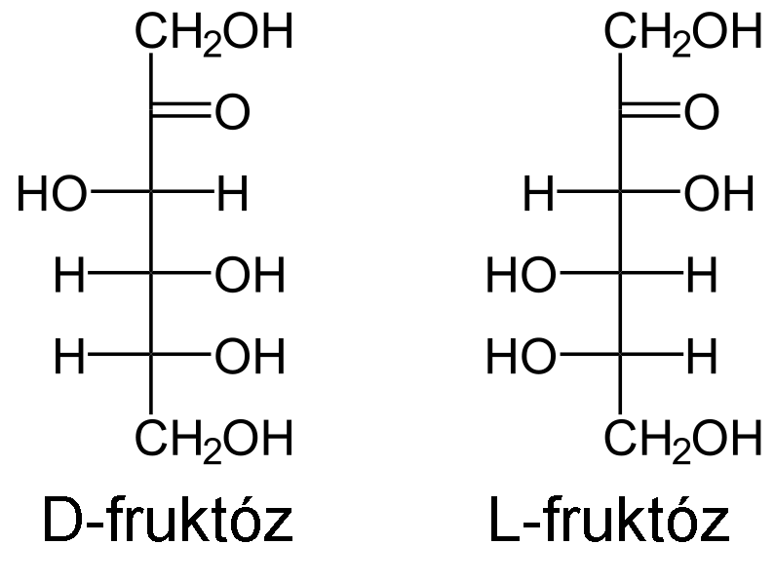

**[2.]** Label if the following sugars are L or D?

|  |  |  |  |
| --- | --- | --- | --- |
| A)  CHO  |  H–C–OH  |  HO–C–H  |  H–C–OH  |  H–C–OH  |  CH2OH | B)  CHO  |  H–C–OH  |  HO–C–H  |  HO–C–H  |  H–C–OH  |  CH2OH | C)  CHO  |  HO–C–H  |  H–C–OH  |  HO–C–H  |  HO–C–H  |  CH2OH | D)  CHO  |  HO–C–H  |  HO–C–H  |  H–C–OH  |  H–C–OH  |  CH2OH |

Give one pair of …:

enantiomers: diastereomers: epimers:

**[3.]** L or D? α or β? Glucose or fructose?

|  |  |  |  |
| --- | --- | --- | --- |
|  | **α or β?** | **L or D?** | **glucose or fructose?** |
|  |  |  |  |
| ***bDglucose*** |  |  |  |
|  |  |  |  |
| **bDfructose** |  |  |  |
|  |  |  |  |

|  |  |  |  |  |
| --- | --- | --- | --- | --- |
|  | RIBOSE | 2-DEOXYRIBOSE | GLUCOSE | FRUCTOSE |
| Structural formula: | ribose | deorib | Fájl:D-glucose color coded.png | http://upload.wikimedia.org/wikipedia/hu/c/cf/DL-Frukt%C3%B3z.png |
| according the no. of sugar units |  |  |  |  |
| according to the oxo group |  |  |  |  |
| colour |  |  |  |  |
| state |  |  |  |  |
| taste |  |  |  |  |
| solubility in water |  |  |  |  |
| pH of aqueous solution |  |  |  |  |
| MP | 95°C | 91°C | 146°C | 103°C |
| scientific name |  |  |  |  |
| importance |  |  |  |  |

|  |  |  |
| --- | --- | --- |
| **Name** | **Maltose** | **Cellobiose** |
| **Other names** |  |  |
| **Composing units** |  |  |
| **Structure** | I:\kémia\12\maltóz.jpg | I:\kémia\12\cellobióz.jpg |
| **Connected by …** |  |  |
| **Molecular formula** |  |  |
| **State, colour, taste, solubility** |  |  |
| **Importance and use** |  |  |
| **Is it reducing sugar?** | yes | yes |
|  |  |  |
| **Name** | **Saccharose** | **Lactose** |
| **Other names** |  |  |
| **Composing units** |  |  |
| **Structure** | I:\kémia\12\szacharóz.jpg | Lactose Formula - Structure, Properties, Uses, and FAQs |
| **Connected by …** |  |  |
| **Molecular formula** |  |  |
| **State, colour, taste** |  |  |
| **Importance and use** |  |  |
| **Is it reducing sugar?** | **no** | yes |

|  |  |  |  |
| --- | --- | --- | --- |
|  | **Starch** | | **Cellulose** |
| **name of subtypes** |  |  | xxxxx |
| **abundance** |  |  | xxxxx |
| **types of glucose** |  |  |  |
| **No. of glucose units** |  |  |  |
| **structure** | http://www.lsbu.ac.uk/water/images/hyamy.gif | http://www.sonefe.org/biomolecules/Amylopectin2.jpg | http://www.doitpoms.ac.uk/tlplib/wood/figures/cellulose.png |
| **details** |  |  |  |
| **water solubility** |  |  |  |
| **biological role,**  **importance** |  |  |  |